

CHAROTAR UNIVERSITY OF SCIENCE AND TECHNOLOGY

FACULTY OF TECHNOLOGY AND ENGINEERING

B. TECH (IT/CE/CSE/AIML)

Practical : 10
Practical Statement:
- Add a background notification system to the Task Management application using Node.js built-in EventEmitter.
- When a task is created through the API, emit a task-created event and handle it in a separate listener.
- The listener logs the task title, timestamp, and assigned user without placing slow notification work in the request path.
- Send the main API response immediately after saving the task; do not wait for the notification listener to finish.
- Log timestamps at the API response point and when background notification handling completes.

Screenshots (Supplementary Problems are also implemented):
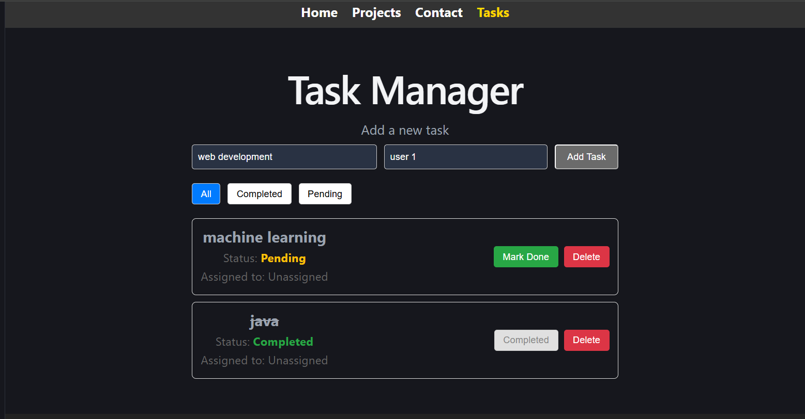
Added task and assigned user

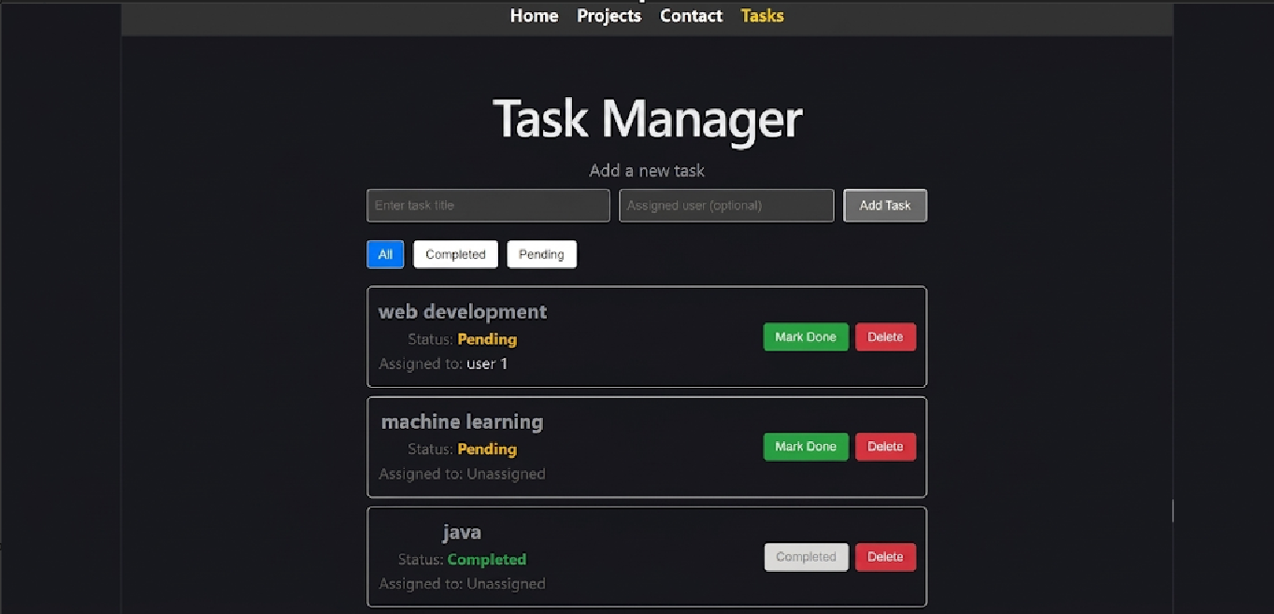
Updated section

Key Questions / Analysis:
1. Why does emitting an event not block the API response, even though both run in the same Node.js process?
Answer: EventEmitter.emit() invokes registered listeners synchronously and does not await a returned Promise. Therefore, the listener must quickly schedule slow work (for example, using setImmediate) and return. In this implementation, the two-second delay and notification run later, so they do not hold up the route after the emit call. EventEmitter is not automatically asynchronous.
2. What would happen to API response time if notification logic were placed directly inside the POST route instead of in an event handler?
Answer: Any slow work performed before the response is sent?such as waiting two seconds for a notification?would increase request latency and keep the request handler busy. Deferring the side effect keeps that work out of the critical response path.
3. Why is EventEmitter reasonable for this application scale, but not for a production system handling millions of events per day?
Answer: EventEmitter is built into Node.js, easy to use, and suitable for lightweight in-process events in a small single-process application. Events are not persisted or shared across processes, and they can be lost if the process crashes or restarts. A high-volume production system generally needs a durable, scalable message broker/queue, retry handling, monitoring, and consumer coordination.
Supplementary Problems:
? Add a task-deleted event with its own listener and a distinct log message.
? Add an error event listener that logs errors from the task-created handler.
? Simulate a slow notification handler with a two-second setTimeout and verify that the API does not await it.
Key Skills Addressed:
- Using Node.js built-in EventEmitter to decouple side effects from the main request flow.
- Designing non-blocking background processing without external message queue infrastructure.
- Understanding the Node.js event loop in an applied context.
- Comparing execution using API and handler timestamps.
Learning Outcome:
Students will be able to implement non-blocking, event-driven background processing using Node.js EventEmitter and explain how deferred side effects keep the main request-response cycle fast.
Lab Session Step-by-Step:
1. Create events.js and export a single EventEmitter instance.
2. Create listeners.js and register task-created, task-deleted, and error listeners.
3. Require listeners.js once from the backend server entry point.
4. Save a task in the POST handler, log the API timestamp, send the 201 response, and emit task-created.
5. Add a two-second asynchronous delay to the notification listener using setTimeout (wrapped in a Promise) and defer its execution with setImmediate.
6. Emit task-deleted only after a task has been found and successfully deleted.
7. Run the server, create and delete tasks with Postman or Thunder Client, and record the response/log order.
Tools / Technology / Resources Required:
- Node.js v18 or later and its built-in events module.
- Express.js and Mongoose.
- Postman or Thunder Client.
- Visual Studio Code.
- Node.js Events and event-loop documentation; Traversy Media Node.js Crash Course.

Github Repo Link: https://github.com/Gauravk6531/Advanced-Web-Development-Frameworks/tree/Practical_6

